**EXERCISE-11**

**Question-1:-**

**Outputs:-**

**dynamic table with three rows and three columns**

**Initial the Hover me is red color**

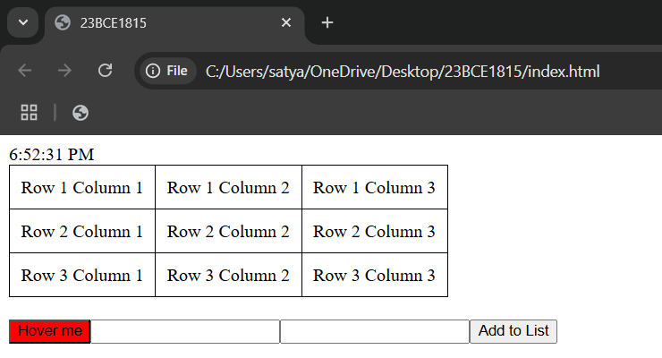

**the color of the Button from red to green color on Mouse Over**

**the color of the Textbox from green to yellow color on Focus and display a greeting message on Change**

**the button is double clicked, add the input text as a new item to an unordered list.**

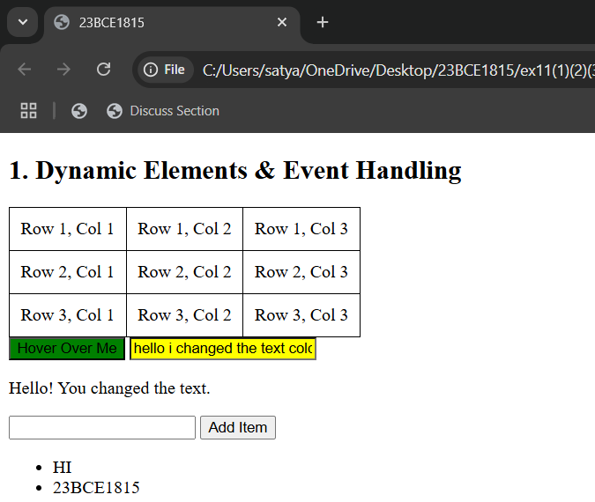

**counting and displaying the number of times any key is pressed.**

**Question-2:-**

**Outputs:-**

**stopwatch with "Start"**

**stopwatch with "Stop"**

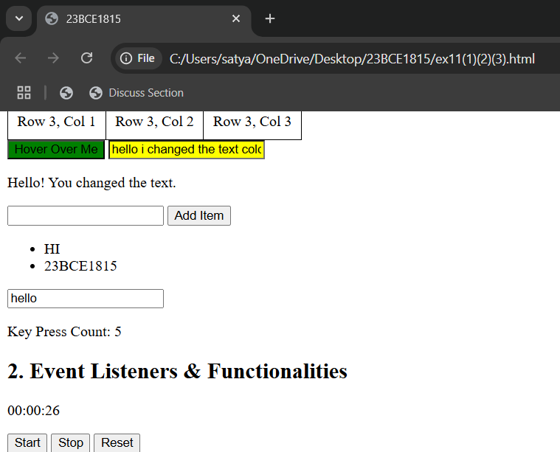

**stopwatch with "Reset"**

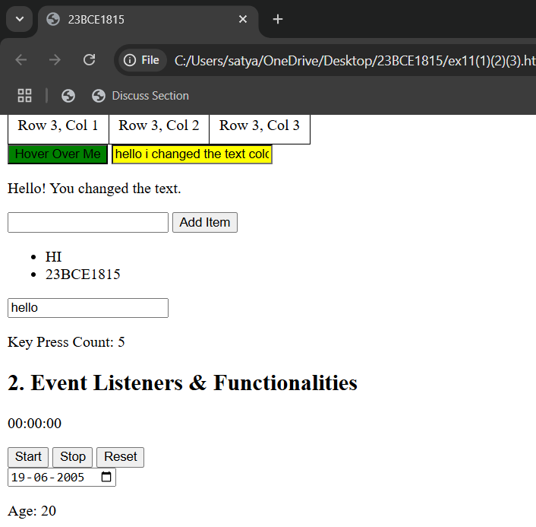

**the Date of Birth and calculate the age on mouseover using an event listener.**

**character counter that updates dynamically as the user types using an event listener**

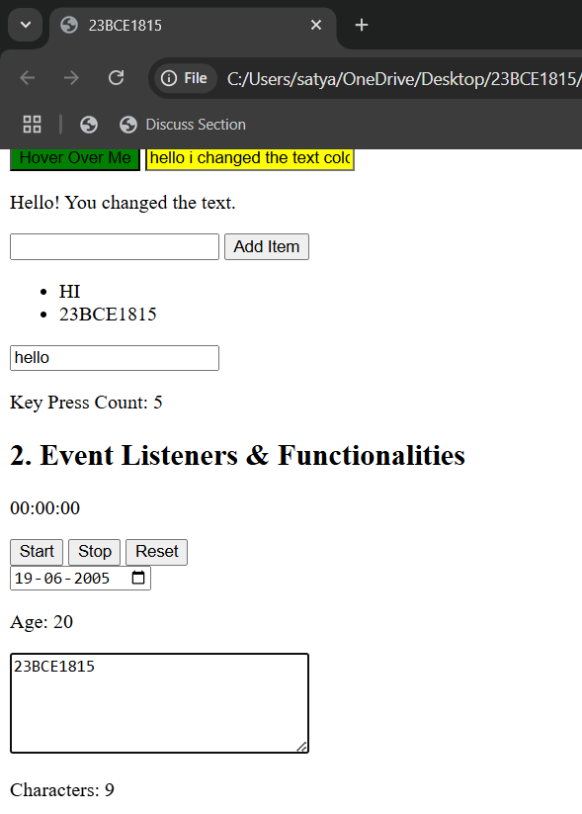

**Question-3:-**

**Outputs:-**

**Without not filling the form Validation**

**With filling the form Validation**

